Job Title | Cleaner
Responsible To | Senior Management
Salary | £8.91 per hour
Hours | 10 hours per week, Monday to Friday 8:30am – 10:30am  Hours to be worked flexibly  Opportunity for additional hours when required
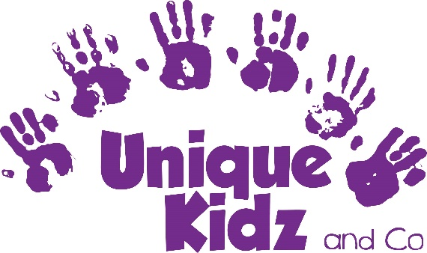

Unique Kidz and Co Overview
Unique Kidz and Co is an award-winning charity that provides social and play opportunities for children and young adults with disabilities and additional needs across Lancaster, Morecambe and the surrounding areas. The charity runs a number of services including afterschool and holiday clubs for children aged 5-19, a siblings group and stay and play sessions for under 5’s. In addition, it runs daytime support sessions for young adults aged 18 – 30. Unique Kidz and Co is a place to play, have fun, make friends and be unique and the specialist care that we provide give parents, carers and families the respite that they need and the opportunity to remain in work.
Job Summary
The Cleaner will be responsible for ensuring that the cleanliness and hygiene at Unique Kidz and Co is of a high standard.
Job Description
- To work under the direction of the Senior Management Team
- Responsible for all basic cleaning in and around the site and building
- Cleaning rooms including; mopping, sweeping, vacuuming, dusting, picking up larger objects off the floor, and spot cleaning glass and windows.
- Cleaning toilets including; restocking dispensers, emptying trash, cleaning and sanitizing fixtures, cleaning mirrors, spot cleaning partition doors and walls, sweeping and mopping tile floors, and cleaning toilets.
- Cleaning kitchen including; mopping, cleaning and sanitizing work surfaces and equipment, spot cleaning internal cupboards and fridges
- Vacuums, empties trash, and replaces liners.
- Sets up, stocks, and maintains cleaning equipment and supplies, ensuring the COSHH policy and procedure is followed at all times.
- Monitors and maintains sanitation and organisation of assigned areas.
- To ensure a high standard of cleanliness at all times
- To safeguard the confidentiality of all service user information and records
- To work to the charity’s Policies and Procedures at all times
- Such other duties or responsibilities as may reasonably be required

This job description will be reviewed regularly in light of changing service requirements and any such changes will be discussed with the post holder.

Person Specification: Cleaner
Requirement | Essential | Desirable | How Assessed
Qualifications | - Level1 safeguarding children and young people or the willingness to attend training | - Relevant cleaning or support skills qualification  - Full, clean UK Driving licence | Application Form
Experience & Knowledge | - Knowledge of good practice  - Knowledge and understanding of Risk Assessments and Health and Safety  - Experience of working in a team | - Knowledge and understanding of children with disabilities  - Experience of driving minibuses | Application Form / Interview
Skills & Abilities | - Excellent communication and organisation skills  - Strong interpersonal and problem-solving abilities  - Highly responsible and reliable  - Ability to work as part of a team  - Skills to measure correct amount of fluids | - Specialist skills and interests that would be of benefit to Unique Kidz and Co | Application Form / Interview
Personal Attributes | - Friendly, positive and professional manner  - Enthusiasm  - Team player | - Commitment to undertaking relevant training and development | Interview
Other | - Evident passion for the charity and excellence in service provision | - Knowledge of Unique Kidz and Co and the services it provides | Interview

